Self-Guided Lab Assignment
Topic: OSI Model, TCP/IP Model &WiresharkPackeAnalysis

OSI Model – Seven Layers Explained

Layer 1 – Physical Layer

The Physical Layer is responsible for the actual transmission of raw bits (0s and 1s) over a physical communication medium. It deals with hardware components like cables, switches, network interface cards, voltage levels, and signal timing. It decides how data moves in the form of electrical signals, light pulses, or radio waves. Examples include Ethernet cables, Fiber optic cables, USB, and Wi-Fi frequency specifications. A real-world analogy is a road or railway track that allows vehicles (data) to travel from one place to another.

Layer 2 – Data Link Layer

The Data Link Layer ensures reliable transfer of data frames between devices connected on the same network. It handles MAC addressing, error detection, and controls access to the physical medium (who can talk when). This layer is divided into two sublayers: MAC (Media Access Control) and LLC (Logical Link Control). Common protocols include Ethernet, Wi-Fi (IEEE 802.11), ARP, and PPP. A real-world analogy is a traffic controller or building security guard who checks IDs and decides who can enter and prevents collisions.

Layer 3 – Network Layer

The Network Layer determines the best path for data to travel across interconnected networks. It deals with logical addressing (IP addresses) and routing packets from source to destination, even across different networks. Key protocols include IP, ICMP, RIP, OSPF, and BGP. Routers work in this layer. A real-world analogy is a postal system, where every house has a unique address and the post office decides the best route to deliver letters.

Layer 4 – Transport Layer

The Transport Layer is responsible for end-to-end communication, error recovery, segmentation of data into smaller chunks, flow control, and reliable or unreliable delivery. It ensures data is delivered completely and in the correct order. The main protocols are TCP (reliable) and UDP (faster but not guaranteed). A real-world analogy is a courier service: TCP is like a courier requiring signature and tracking, while UDP is like normal post without tracking.

Layer 5 – Session Layer

The Session Layer manages and controls communication sessions between two devices. It establishes, maintains, and terminates the communication session, ensuring that both sides stay connected while transferring data. It also handles dialog control (who speaks when). Protocol examples include RPC, PPTP, NetBIOS, and NFS. A real-world analogy is a telephone call, where you start a call, talk, and hang up once done.

Layer 6 – Presentation Layer

The Presentation Layer focuses on data formatting, translation, encryption, and compression so that the receiving system can understand the information. It converts data to a standard format such as ASCII, JPEG, MPEG, or encryption formats like SSL/TLS. A real-world analogy is a translator who converts one language into another so both sides understand each other.

Layer 7 – Application Layer

The Application Layer is the closest layer to the user, providing network services directly to applications such as web browsers, email clients, and messaging apps. It supports functions like file transfer, email communication, remote login, and web browsing. Examples of protocols include HTTP, HTTPS, FTP, DNS, SMTP, POP3, and DHCP. A real-world analogy is a restaurant where the user interacts with the menu, placing orders and receiving service.

OSI Mnemonic

“Please Don’t Nail These Soft Pink Apples”

Word OSI Layer Meaning / Mapping

Please- Layer 1 – Physical Reminds us of the physical hardware and signals
Don’t- Layer 2 – Data Link Data is linked and controlled between devices
Nail- Layer 3 – Network Networks route packets like mail delivery
These- Layer 4 – Transport Transports reliable data end-to-end
Soft- Layer 5 – Session Soft connections (sessions) are created and ended
Pink- Layer 6 – Presentation Presentation layer formats data so it looks right
Apples- Layer 7 – Application Applications used by the end user

Explanation

This mnemonic helps remember the layers in the correct order starting from the lowest layer (Physical) to the highest (Application). Each word is the first letter of the layer name, making it easy to recall during exams or networking tasks. By visualizing something funny like “soft pink apples”, the brain remembers the sequence more easily.

OSI vs TCP/IP Model Comparison

The OSI Model is a conceptual framework with seven layers that explains how data travels across a network step by step. It is mainly used for understanding and teaching network communication. On the other hand, the TCP/IP Model is a more practical, real-world model with four layers, used in actual networking and the Internet. While OSI separates functions into more detailed layers (especially the top three: Session, Presentation, Application), TCP/IP combines these into one layer called the Application layer.

The TCP/IP model was developed earlier and is based on standardized Internet protocols such as IP, TCP, and UDP, making it widely implemented in real networks. The OSI model helps network engineers troubleshoot and design systems, while the TCP/IP model helps implement communication in real devices. Both models serve the same goal—successful data communication—just with different structural approaches.

Mapping Table – OSI vs TCP/IP

OSI Layer TCP/IP Layer

Application / Presentation / Session (L7/L6/L5) Application Layer
Transport (L4) Transport Layer
Network (L3) Internet Layer
Data Link / Physical (L2/L1) Network Access Layer

Protocol Data Units (PDUs) – Lower Layers

OSI Layer PDU Name

Layer 4 – Transport Segments (TCP) / Datagrams (UDP)
Layer 3 – Network Packets
Layer 2 – Data Link Frames
Layer 1 – Physical Bits

Explanation

At the Transport Layer, data is broken into segments if the connection is reliable using TCP, or datagrams when using an unreliable fast protocol like UDP.

At the Network Layer, the data unit is called a packet, containing the IP address for routing across networks.

At the Data Link Layer, packets are wrapped into frames, which include MAC addresses and error checking for communication within the same network.

At the Physical Layer, frames are converted into bits—binary electrical/optical signals—sent across the medium like cables or radio waves.

Addressing Concepts in OSI Layers

MAC Address – used at Layer 2 (Data Link)

A MAC Address (Media Access Control Address) is a unique hardware address assigned to a network interface card (NIC) by the manufacturer. It is used to identify devices within the same local network, such as computers connected to the same Wi-Fi router or switch. MAC addresses work only within the local network and do not travel beyond routers. They help deliver frames from one device to another on the same network segment. MAC addressing belongs to the Data Link Layer (Layer 2) of the OSI model.

IP Address – used at Layer 3 (Network)

An IP Address (Internet Protocol Address) is a logical address used to identify devices across different networks and provide routing information so packets can travel from source to destination anywhere in the world. IP addresses allow communication beyond local networks, unlike MAC addresses. IPv4 (e.g., 192.168.1.10) and IPv6 are common formats. IP addressing belongs to the Network Layer (Layer 3) of the OSI model and is handled mainly by routers.

Port Number – used at Layer 4 (Transport)

A Port Number is used to identify specific applications or services running on a device so that data reaches the correct program (like browser, email, or game). While the IP address identifies which device to send data to, the port number identifies which application on that device should receive it. Examples include Port 80 for HTTP, 443 for HTTPS, 25 for SMTP, 53 for DNS. Port numbers are part of Transport Layer (Layer 4) and are used in TCP and UDP communication.

Wireshark Practical

1. HTTP Traffic (Application over TCP)
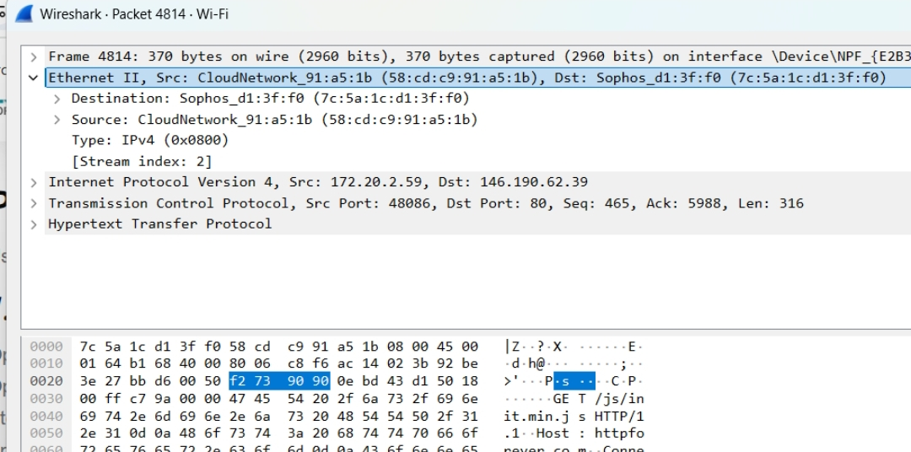
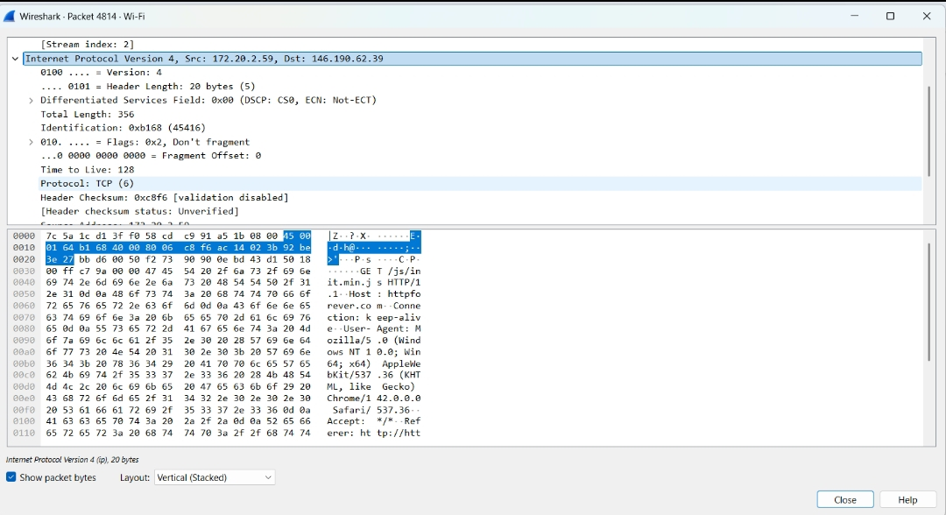

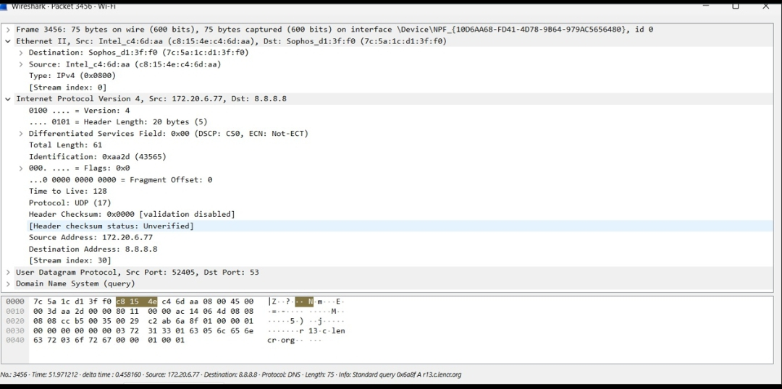
2.ICMP Packets

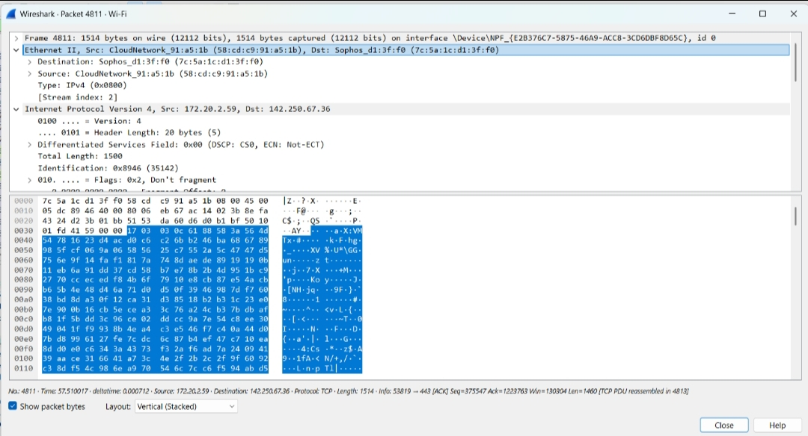
3. TCP Packets

4. UDP Packets
